EXP NO: 02 DATE:

DEVELOP A C PROGRAM TO ANALYSER A GIVEN C CODE SNIPPET AND

# RECOGNIZE DIFFERENT TOKENS, INCLUDING KEYWORD, IDENTIFIERS, OPERATOR, DELIMITER AND SPECIAL SYMBOLS

AIM:

To develop a C program that analyses a given C code snippet and recognizes different tokens, including keywords, identifiers, operators, delimiter and special symbols.

ALGORITHM:

* Start
* Take a C code snippet as input from the user or a file.
* Initialize necessary arrays and variables for keywords, identifiers, operators, and special symbols.
* Tokenize the input string using spaces, newlines, and other delimiters.
* For each token:

* Check if it is a keyword (compare with a predefined list of C keywords).
* Check if it is an identifier (valid variable/function name that doesn’t match a keyword).
* Check if it is an operator (e.g., +, -, *, /, ==, &&).
* Check if it is a special symbol (e.g., {, }, (, ), ;, ,).
* Print the categorized tokens.
* End

PROGRAM:

#include <stdio.h>

#include <string.h>

#include <ctype.h>

int main() { char input[100];

char *str[] = {"int","float","long","double","printf"}; int i=0,j=0,iskeyword=0; scanf("%[^END]s",input);

for(i=0;i<4;i++){ int flag=1; for(j=0;str[i][j]!='\0';j++){ if(input[j]!=str[i][j]){ flag=0; break;

} } if(flag) { iskeyword = 1; printf("%s is a keyword\n", str[i]); break;

}

}

int start = j; while(input[start]!='\0'){ if(isalpha(input[start])){ printf("%c",input[start]); start++;

while(isalnum(input[start]) || input[start]=='_'){ printf("%c",input[start]); start++; } printf(" is a identifier\n"); }else if(isdigit(input[start])){ printf("%c",input[start]); start++; while(isdigit(input[start])){ printf("%c",input[start]); start++;

}

printf(" is a constant\n");

}else if(input[start]==',' || input[start]==';'){ printf("%c is a delimeter\n",input[start]);

start++;

}else if(input[start]=='+' ||input[start]=='-' || input[start]=='*' || input[start]=='/' || input[start]=='%' || input[start]=='=' ){ printf("%c is a operator\n",input[start]); start++;

}else if(input[start]=='(' ||input[start]==')' || input[start]=='{' || input[start]=='}' || input[start]=='[' || input[start]==']' ){ printf("%c is a Symbol\n",input[start]); start++; }else{ start++;

} } return 0;

}

OUTPUT:

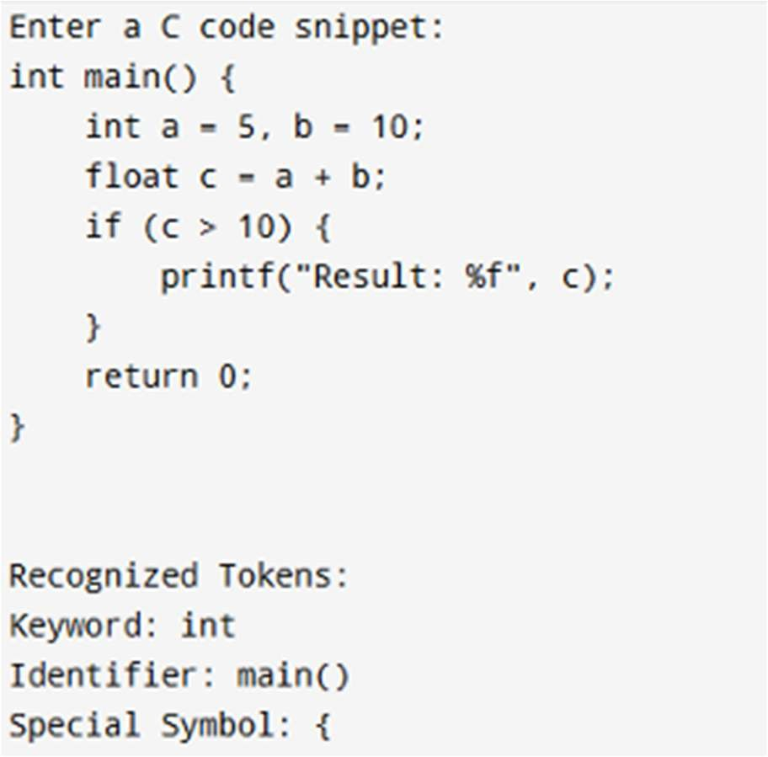

|  |  |
| --- | --- |
| Implementation |  |
| Output/Signature |  |

RESULT :

Thus the above program reads a C code snippet, tokenizes it using space, tab, and newline as delimiters, classifies each token as a keyword, identifier, operator, or special symbol based on predefined lists, and prints the recognized tokens along with their types